1.Brand and business set up

**Business Name:**

**NeuroBrand AI**

**Tagline:**

**"Branding at the Speed of Thought."**

**Brand Story:**

In a world where attention spans are measured in seconds and innovation happens overnight, startups need more than just a logo—they need an identity that evolves as fast as they do.

That’s why we created **NeuroBrand AI**, a next‑generation digital branding agency where artificial intelligence meets human creativity. We don’t just design—we predict. Our proprietary AI analyzes market trends, competitor moves, and audience behavior in real‑time, crafting brand identities that adapt, learn, and grow with your business.

For founders chasing big dreams, we’re more than a design partner—we’re your brand’s personal strategist, storyteller, and growth hacker, all rolled into one. Whether you’re launching your first product, seeking investment, or preparing to dominate your industry, NeuroBrand AI makes sure your brand voice is loud, clear, and unforgettable.

Because in the future of business, the winners won’t just be the fastest or the smartest—they’ll be the ones who can **think in brand**.

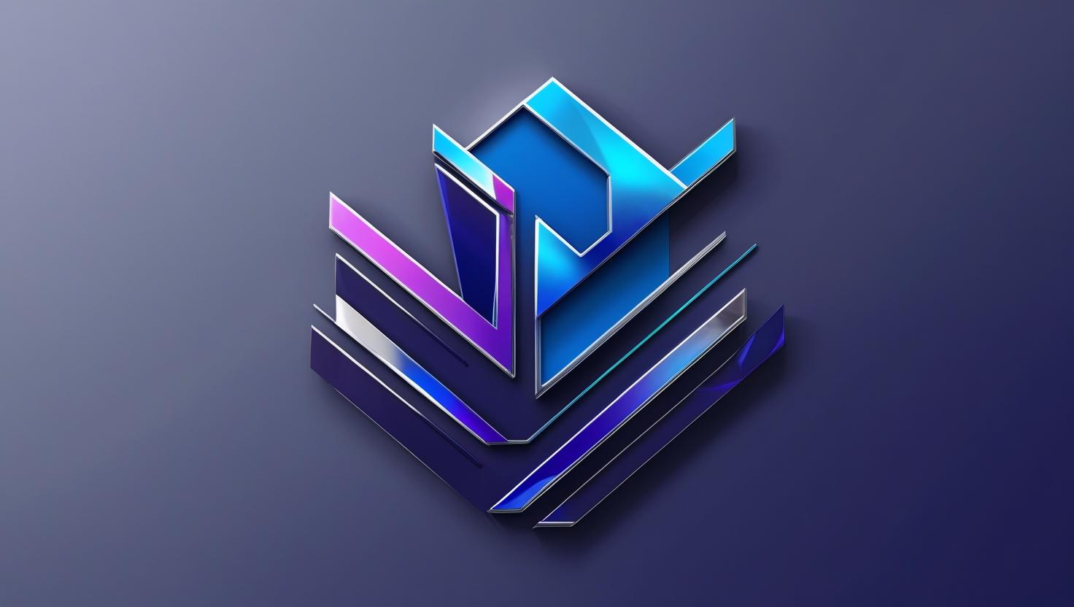

**NEUROBRAND AI LOGO**

2. design and markering content 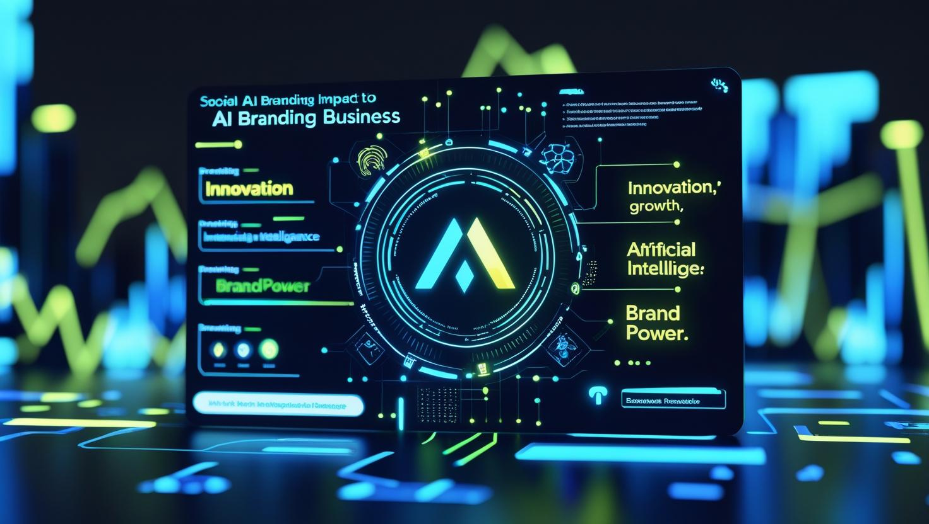

**Why AI-Powered Branding Is the Key to Staying Competitive in the Modern Market**

In today’s hyper-connected world, the way people see your brand can change in seconds. A trending social media post, a viral competitor campaign, or a sudden market shift can instantly redefine your audience’s expectations. In this fast-moving environment, businesses—especially startups—can’t afford to rely solely on traditional branding strategies.

This is where **AI-powered branding services** step in, transforming brand creation, management, and evolution into a real-time, data-driven process.

**1. Branding at the Speed of Change**

The modern market doesn’t wait for anyone. Competitor innovations, cultural trends, and even meme culture can influence your customers overnight. AI-powered branding tools track these changes continuously, allowing your brand identity, messaging, and visuals to adapt instantly—without waiting for lengthy human brainstorming sessions.

**2. Hyper-Personalized Brand Experiences**

Generic branding is invisible in today’s crowded market. AI allows businesses to tailor their brand voice, visual identity, and marketing campaigns to specific customer segments based on real-time behavioral insights. This level of personalization builds stronger emotional connections and increases brand loyalty.

**3. Predictive Branding, Not Reactive**

Most branding strategies focus on reacting to the present. AI turns that around. By analyzing market data, social trends, and competitor moves, AI can forecast emerging trends before they explode. This means your brand can lead rather than follow—positioning you as an innovator in your industry.

**4. Cost-Effective and Scalable**

Building a strong brand has traditionally required expensive creative agencies, countless hours of design revisions, and months of planning. AI-powered branding streamlines the process, producing high-quality designs, brand messaging, and content in minutes. This efficiency frees up resources for growth, product development, or scaling your marketing reach.

**5. Consistency Across Every Touchpoint**

Inconsistent branding is one of the fastest ways to lose credibility. AI ensures your brand identity stays unified across websites, social media, ads, packaging, and presentations—automatically adjusting for different formats without losing your brand’s essence.

**The Future Is AI-Driven Branding**

Branding has always been about making an emotional connection, but in today’s digital-first world, it’s also about speed, precision, and adaptability. AI doesn’t replace human creativity—it amplifies it, helping businesses craft compelling brand stories while staying ahead of market shifts.

For startups and ambitious companies, embracing AI-powered branding is no longer a luxury—it’s a competitive necessity.

If your competitors are still branding the old-fashioned way, now is the perfect time to lead the charge.

3. a persuasive email to clients

**Subject:** Unlock the Future of Your Brand with AI-Driven Creativity 🚀

Hi Henry,

I hope this message finds you well. I wanted to share something that could give your business a significant competitive edge—**AI-powered branding**.

In today’s fast-moving market, your brand needs to do more than look good—it needs to evolve, adapt, and resonate with your audience in real time. That’s where AI comes in.

At **NeuroBrand AI**, we combine advanced artificial intelligence with human creativity to craft brand identities that are not only visually stunning but also strategically designed for growth.

Here’s how AI-generated branding can elevate your business:

* **Branding at the Speed of Change** – Instantly adapt your visuals, messaging, and campaigns to market trends.
* **Hyper-Personalization** – Speak directly to your ideal customers with tailored, data-driven creative assets.
* **Predictive Insights** – Stay ahead by anticipating market shifts before your competitors do.
* **Consistent Brand Identity** – Maintain a unified brand presence across all platforms effortlessly.

The result? A stronger connection with your audience, increased visibility, and a brand that feels alive and future-ready.

If you’re open to exploring how this could transform your business presence, I’d love to schedule a quick call and walk you through what AI-powered branding could look like for you.

Looking forward to hearing your thoughts.

Best regards,  
**[Your Name]**  
Founder & Creative Director  
**NeuroBrand AI**  
Branding at the Speed of Thought  
[Your Website]

**slide on the advantage of AI**

